BSCS FINAL PROJECT
Design and Test Specification

FLOWMIND AI



Project Advisor

Shah Nawaz

Presented by:

Group ID: F24SE042

Student Reg# Student Name
L1F21BSSE0500 Hassan Raza
L1F20BSSE0007 Muskan Amjad
L1F21BSSE0570 Muhammad Talha

Faculty of Information Technology

University of Central Punjab
Design and Test Specification
SDP Phase III

FLOWMIND AI
Advisor: Shah Nawaz

Team F24SE042
Member Name | Primary Responsibility
Hassan Raza | Documentation and Project plan
Muskan Amjad | Documentation and UML
Muhammad Talha | UML

Table of Contents
Table of Contents i
Revision History ii
Abstract iii
1. Introduction 1
1.1 Product 1
1.2 Background 1
1.3 Objective(s)/Aim(s)/Target(s) 1
1.4 Scope 1
1.5 Business Goals 1
1.6 Document Conventions 1
1.7 Miscellaneous 1
2. Technical Architecture 2
2.1 Application and Data Architecture 2
2.2 Component Interactions and Collaborations 2
2.3 Design Reuse and Design Patterns 3
2.4 Technology Architecture 3
2.5 Architecture Evaluation 3
3. Detailed/Component Design 4
3.1 Component-Component Interface 4
3.2 Component-External Entities Interface 4
3.3 Component-Human Interface 4
4. Screenshots/Prototype 4
4.1 Workflow 4
4.2 Screens 4
4.3 Additional Information 4
5. Other Design Details 5
6. Test Specification and Results 5
6.1 Test Case Specification 5
6.2 Summary of Test Results 6
7. Revised Project Plan 6
8. References 7
Appendix A: Glossary 8
Appendix B: IV & V Report 9

Revision History
Name | Date | Reason For Changes | Version

Abstract
FlowMind AI addresses the challenge of manually creating system modeling diagrams such as flowcharts, use case diagrams, and sequence diagrams, which are time-consuming and error-prone for developers and analysts. The significance of this problem lies in improving productivity and accuracy in software design and documentation. This project leverages knowledge areas including React.js for front-end development, Mermaid.js for diagram rendering, and PDF export libraries (jsPDF, html2canvas) to deliver an automated diagram generation tool. The result is a web-based application that allows users to generate, customize, and export diagrams with ease, contributing to efficient system modeling workflows.

Introduction
FlowMind AI is a web-based tool designed to automate the creation of system modeling diagrams, reducing the manual effort required to design flowcharts, use case diagrams, sequence diagrams, and data flow diagrams (DFDs). As of Phase III, the project has progressed to a functional prototype with a responsive user interface, implemented using React.js and styled with CSS. The tool integrates Mermaid.js for diagram rendering and provides export options (PNG/PDF) using jsPDF and html2canvas. The introduction now includes insights into the technical architecture and initial testing results, reflecting the system’s evolution from conceptual design to a testable application.

Product
FlowMind AI is a web-based software tool that automates the generation of system modeling diagrams. It solves the problem of manual diagram creation, which is labor-intensive and prone to errors, by allowing users to input structured data and generate diagrams instantly. The end product is a program that applies algorithms to process user inputs and render diagrams using Mermaid.js, with features for customization and export. Users can create flowcharts, use case diagrams, sequence diagrams, and DFDs, making it a practical tool for software engineers, analysts, and students in system design and documentation tasks.

Background
Previous work in this domain includes tools like Lucidchart, Draw.io, and Visio, which offer manual or semi-automated diagram creation with drag-and-drop interfaces. However, these tools require significant user effort and lack automation for structured inputs. Mermaid.js-based solutions exist (e.g., Mermaid Live Editor), but they are limited to rendering static diagrams without export capabilities or a polished user interface. FlowMind AI differentiates itself by automating diagram generation from text inputs, providing export options (PNG/PDF), and offering a responsive, React-based interface. Related projects from the UCP Project Office list include “Automated UML Generator” (2022), which focused on UML diagrams but lacked export functionality, unlike FlowMind AI’s broader scope and export features.

Objective(s)/Aim(s)/Target(s)
- Develop a web-based tool to automate the generation of system modeling diagrams (flowcharts, use case diagrams, sequence diagrams, DFDs) from structured inputs.
- Enable users to customize diagrams and export them as PNG or PDF files.
- Provide a responsive and user-friendly interface accessible on desktop and mobile devices.
- Contribute to the software engineering domain by improving efficiency in system modeling and documentation within the 6-month FYP timeline.

• Scope
The scope of FlowMind AI includes:
- Generation of flowcharts, use case diagrams, sequence diagrams, and DFDs.
- A web interface built with React.js for diagram creation and customization.
- Export functionality for PNG and PDF formats using jsPDF and html2canvas.
- Responsive design supporting desktop and mobile devices.
- A contact form for user feedback. The project does not include advanced AI for natural language processing to generate diagrams from unstructured text or integration with external databases for real-time data.

Business Goals
- Enhance productivity for software engineers and analysts by automating diagram creation.
- Reduce errors in manual diagram design, improving documentation quality.
- Provide a cost-free tool to students and small teams, addressing the need for affordable diagramming solutions.
- Establish a foundation for future commercial development or API integration.

Document Conventions
- Italics: Used for external systems or tools (e.g., Mermaid.js, React.js).
- Bold: Highlights key components or features (e.g., Diagram Generation, Export Options). Code Font: Used for code snippets, file paths, or commands (e.g., npm start, src/components/Navbar.js).

Miscellaneous
- The team uses GitHub for version control and collaborates weekly to integrate changes.
- Regular meetings with the advisor (Shah Nawaz) are scheduled to review progress.

Technical Architecture

Application and Data Architecture
High-Level Architecture Diagram:
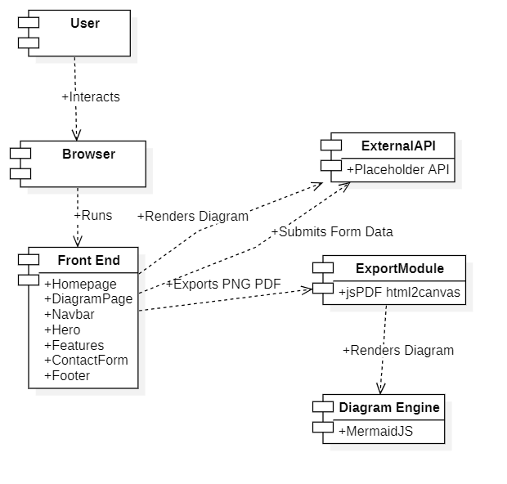

Component Diagram

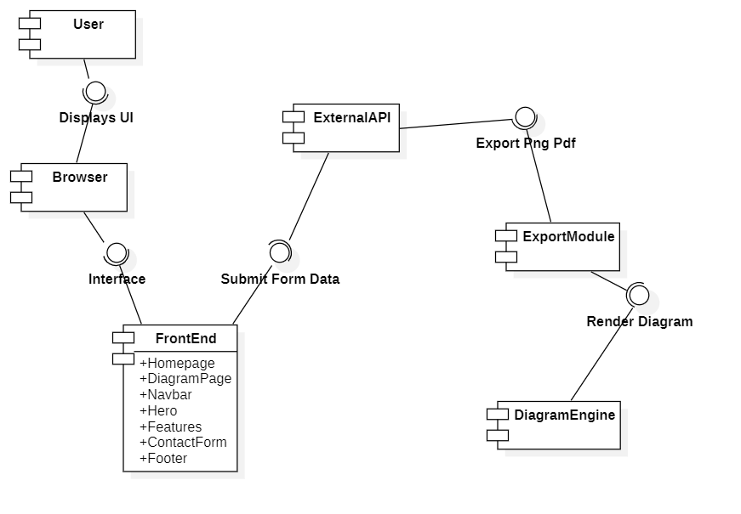

ER Diagram

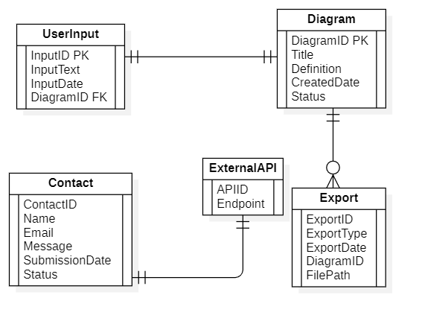

Class Diagram

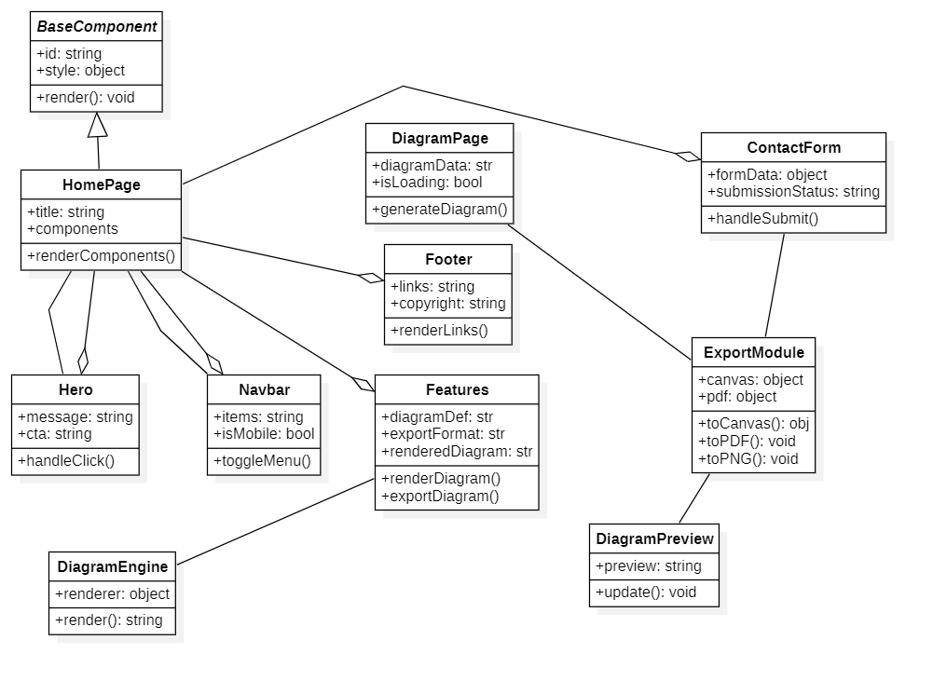

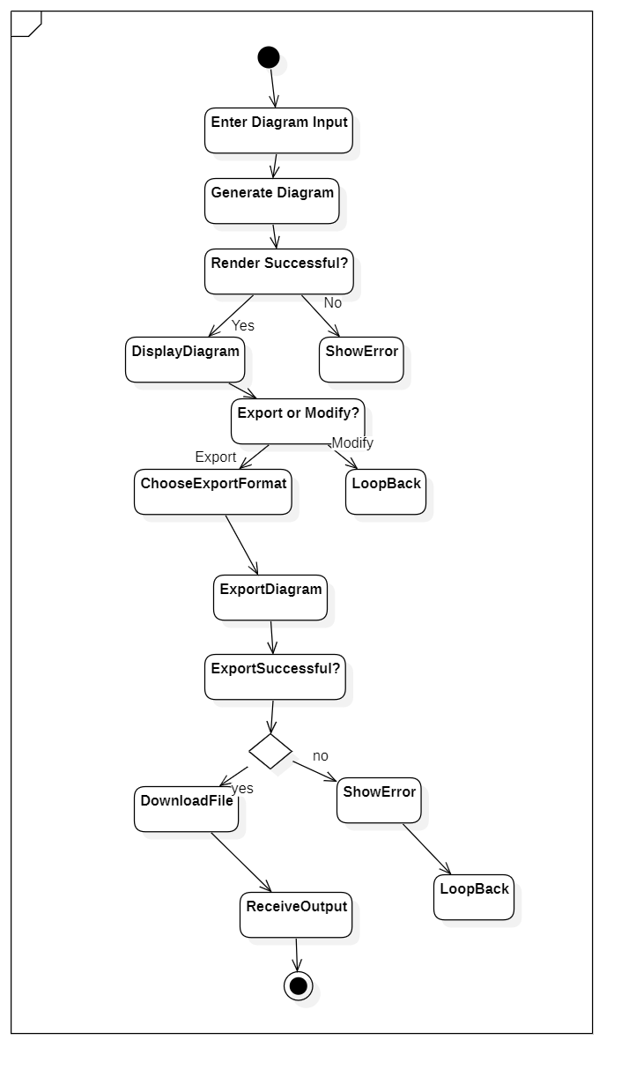
Activity

Decision Table:

Condition | C1: Valid Login? | C2: Diagram Type Selected? | C3: Manual Data Input? | C4: Edit Required? | C5: Export Format Selected?
Rule 1 | Yes | Yes | Yes | No | Yes
Rule 2 | Yes | Yes | No | Yes | Yes
Rule 3 | Yes | No | - | - | -
Rule 4 | No | - | - | - | -
Rule 5 | Yes | Yes | Yes | Yes | No

Component Interactions and Collaborations
SequenceDiagram

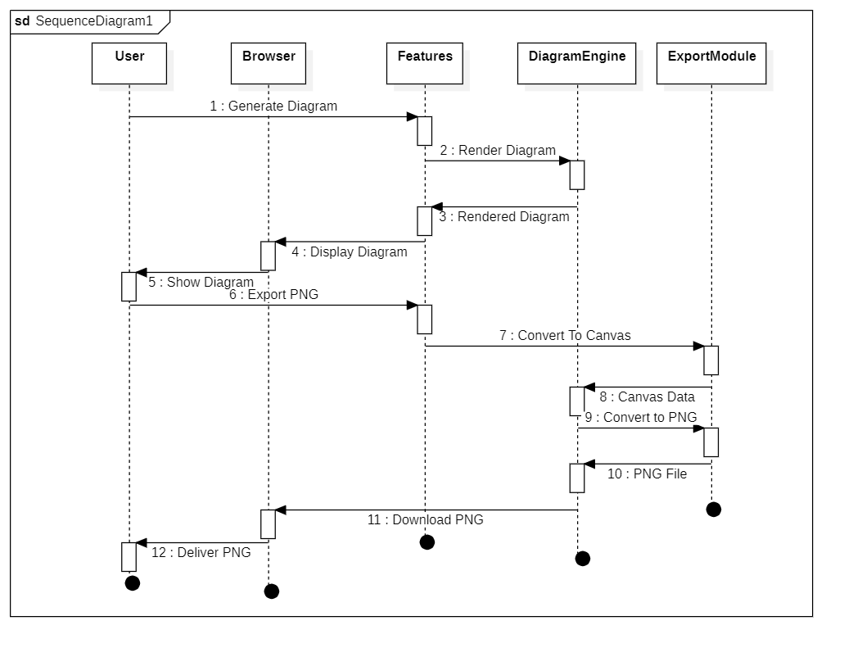

Collaboration Diagram,
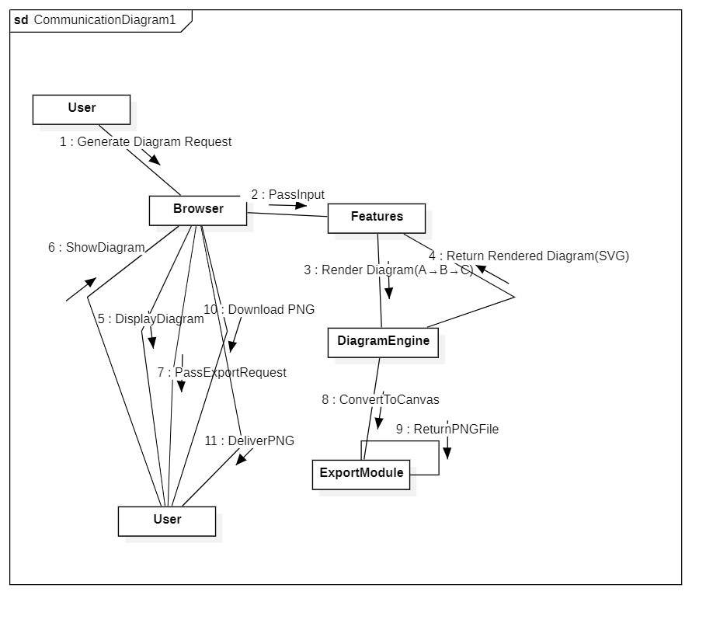

Event traces

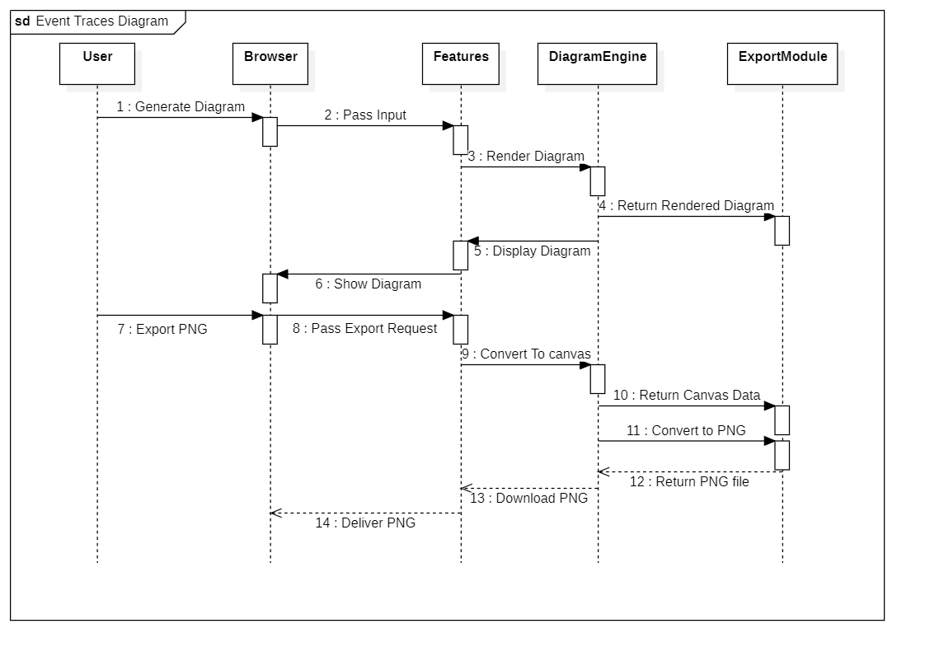

Dfd lvl 0

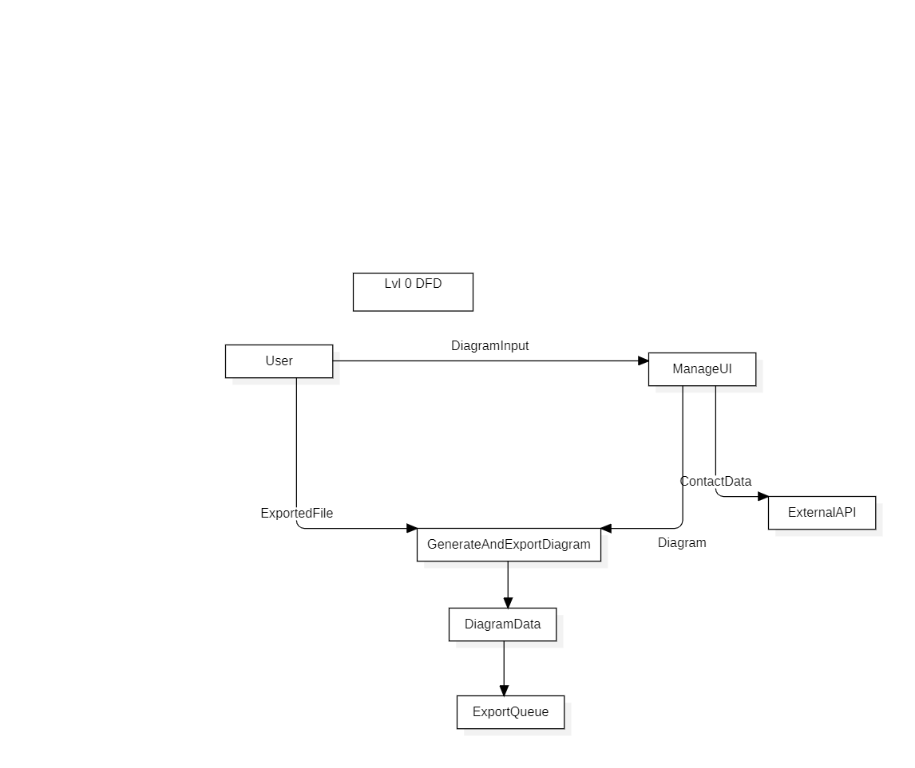

Dfd lvl 1:

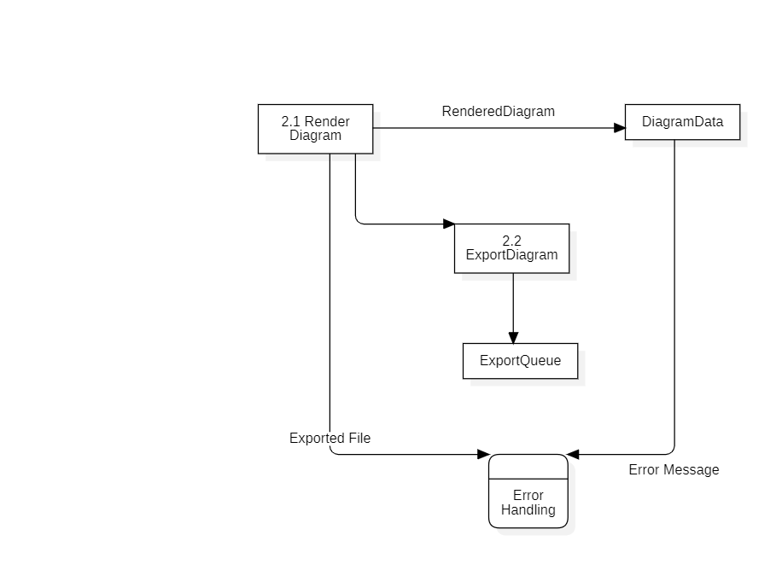

Activity diagram

Design Reuse and Design Patterns
- Reuse: Utilizes open-source libraries (Mermaid.js, jsPDF, html2canvas) and React Router for navigation.
- Patterns: Follows the Model-View-Controller (MVC) pattern conceptually, with React components as the View, state as the Model, and event handlers as the Controller.

Technology Architecture
- Platform: Web-based, custom-built using React.js.
- Processing: Online, real-time processing for diagram generation.
- Components: Navbar, Hero, Features, ContactForm, Footer.
- Data: Temporary user inputs managed in React state.
- Language: JavaScript (ES6+) with React.
- Hardware: Any modern browser on desktop/mobile (no specific server hardware).
- Database: None; transient data only.
- Interface: Browser-based UI with HTML/CSS/JavaScript.
- Network: Accessible via LAN/WAN/Internet.
- Hosting: Planned for deployment on Netlify or Vercel.

Architecture Evaluation
- Decision: Chosen React.js for its SPA capabilities and large community support over alternatives like Angular or Vue.js.
- Pros: Rapid development, responsive design, rich ecosystem.
- Cons: Initial learning curve, performance overhead with large apps.
- Alternative: Vue.js was considered but rejected due to less familiarity within the team.

Detailed/Component Design

Component-Component Interface
- Sequence Diagram: Shows Navbar passing navigation events to HomePage, and Features triggering export functions.

- Collaboration Diagram:

Component-External Entities Interface
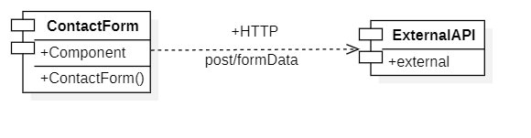

Component-Human Interface
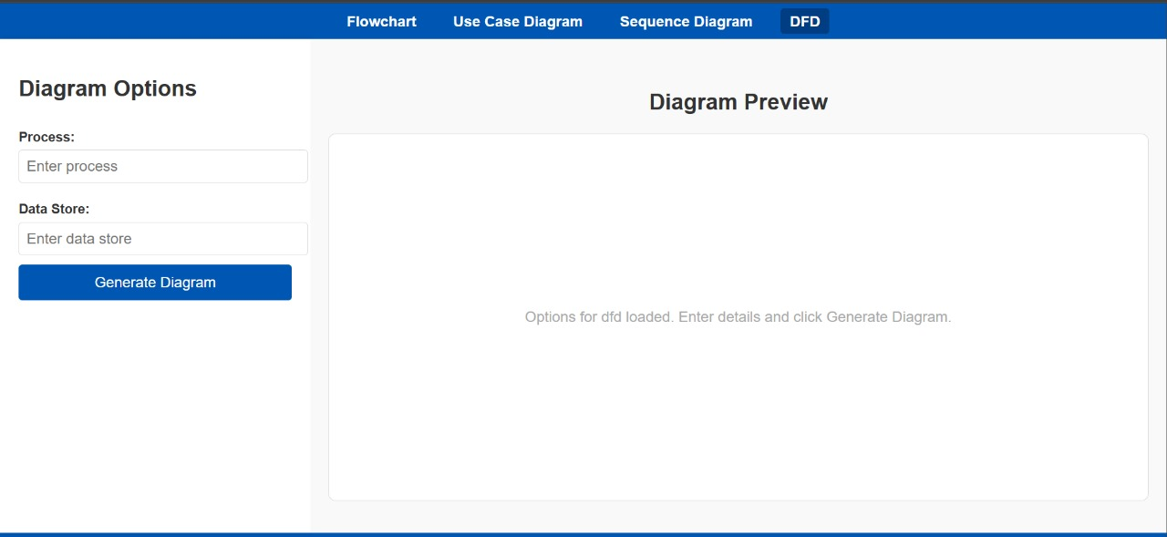

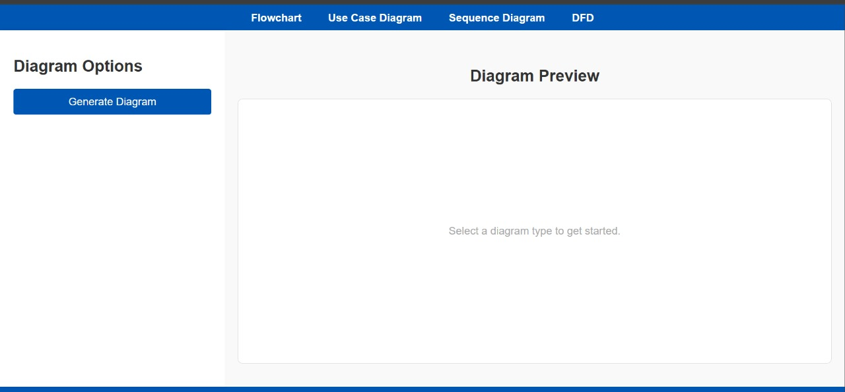

Screenshots/Prototype

Workflow
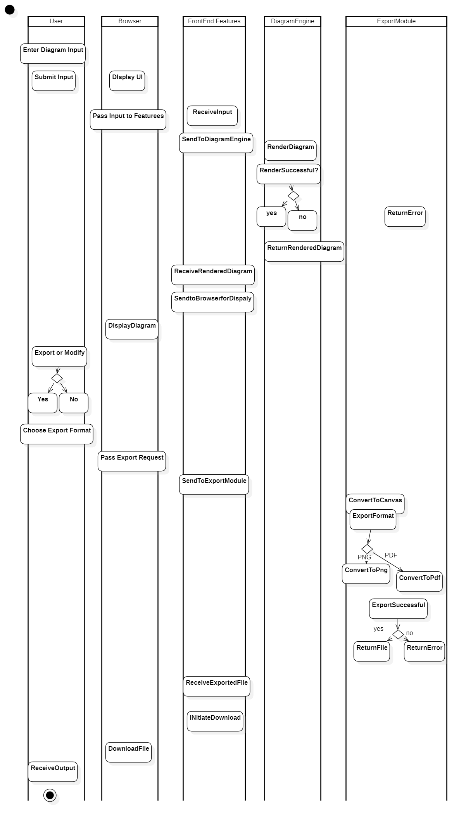

- Swim-Lane Diagram: Shows user actions (input → generate → export) and system responses (render → save).
- Description: User inputs data, system renders a diagram, user customizes and exports it.

Screens
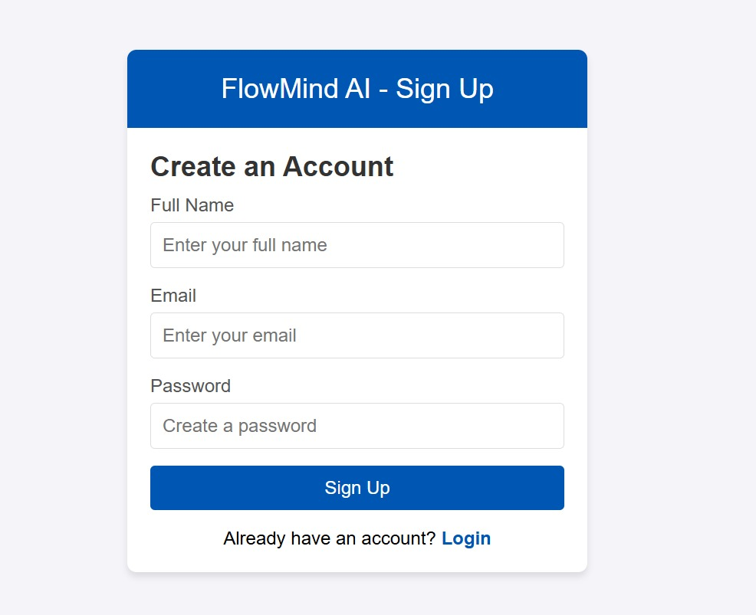

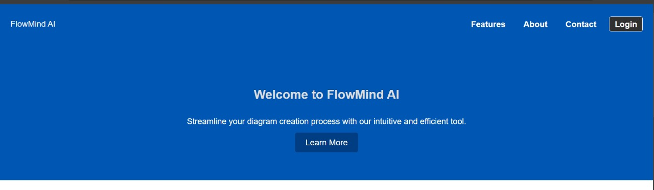

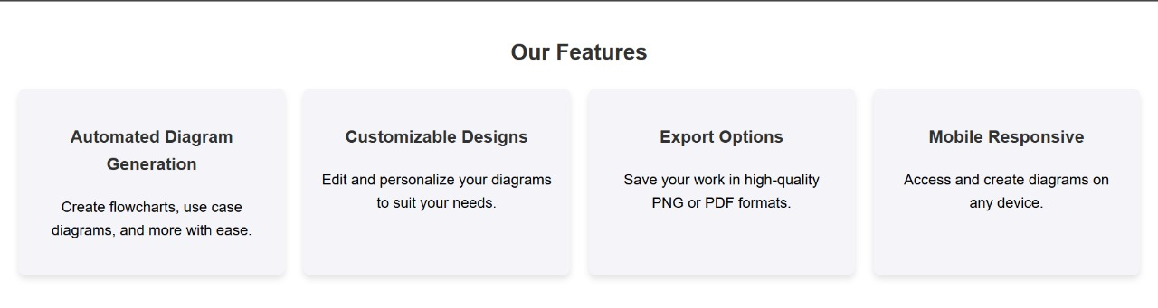

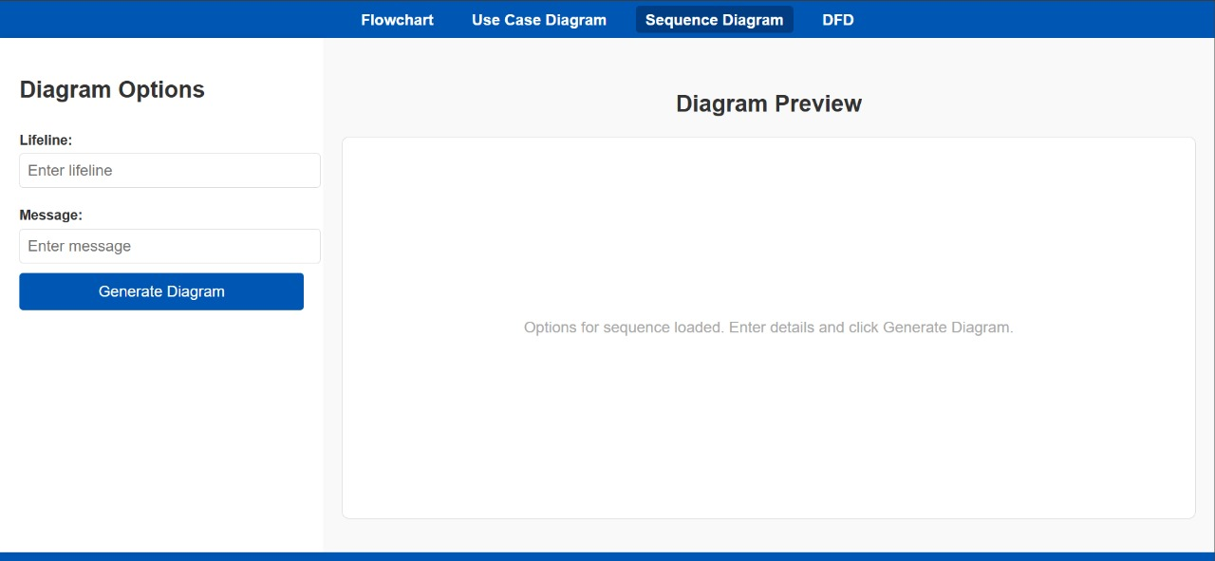

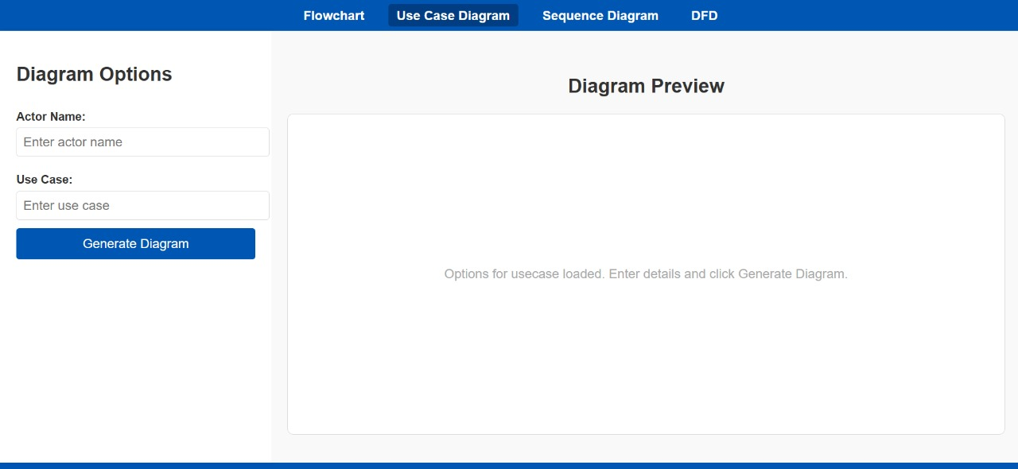

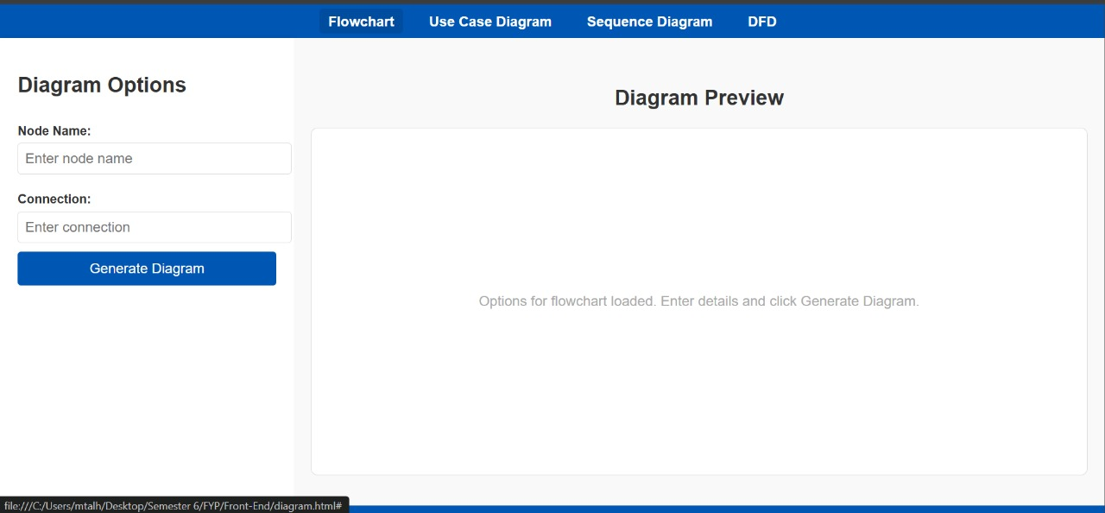

Additional Information
In future phases, FlowMind AI aims to implement a backend server for persistent diagram storage, user authentication for personalized accounts, and integration with a payment gateway for premium export features (e.g., high-resolution PNG/PDF). Additionally, we plan to support more diagram types (e.g., UML, ER) via enhanced Mermaid.js integration and add real-time collaboration using WebSocket.

Other Design Details

Performance Optimization
FlowMind AI is designed for efficiency in diagram rendering and export:
- Lazy Loading of Libraries: Mermaid.js and jsPDF/html2canvas are lazy-loaded to reduce initial load time, improving the user experience on the client side.
- React Memoization: The DiagramPage component uses React’s useMemo to prevent unnecessary re-renders during diagram generation, especially for large diagrams (e.g., complex flowcharts with 50+ nodes).
- Debouncing Input: The input form debounces user input (500ms delay) to avoid excessive API calls or rendering requests, optimizing performance during rapid typing.

Accessibility (a11y) Design
To ensure inclusivity, FlowMind AI incorporates accessibility features:
- Keyboard Navigation: All interactive elements (e.g., form inputs, export buttons) are navigable via keyboard (Tab, Enter keys).
- ARIA Labels: The diagram preview area includes ARIA labels (e.g., aria-label="Diagram Preview") to support screen readers.
- Color Contrast: UI elements adhere to WCAG 2.1 AA standards (e.g., contrast ratio of 4.5:1 for text), ensuring readability for visually impaired users.

Scalability Considerations
FlowMind AI’s current client-side design can be scaled in future phases:
- Backend Integration: Plans for a Node.js/Express backend to store diagrams in a MongoDB database, using REST APIs for CRUD operations.
- Load Balancing: If deployed on a cloud server (e.g., AWS), future implementations will use Elastic Load Balancer to distribute traffic across multiple instances.
- Caching: Introduce Redis caching for frequently accessed diagrams to reduce rendering overhead.

Security Design
To protect user data and ensure secure interactions:
- HTTPS for API Calls: Contact form submissions to the ExternalAPI (https://jsonplaceholder.typicode.com) use HTTPS to encrypt data in transit.
- Input Sanitization: User inputs are sanitized to prevent XSS attacks (e.g., using DOMPurify for diagram definitions).
- CORS Configuration: When a backend is added, CORS will be configured to restrict API access to trusted domains.

Test Specification and Results

Test Case Specification
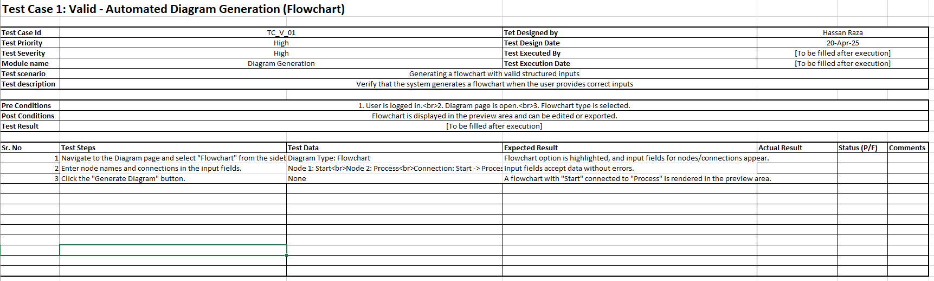

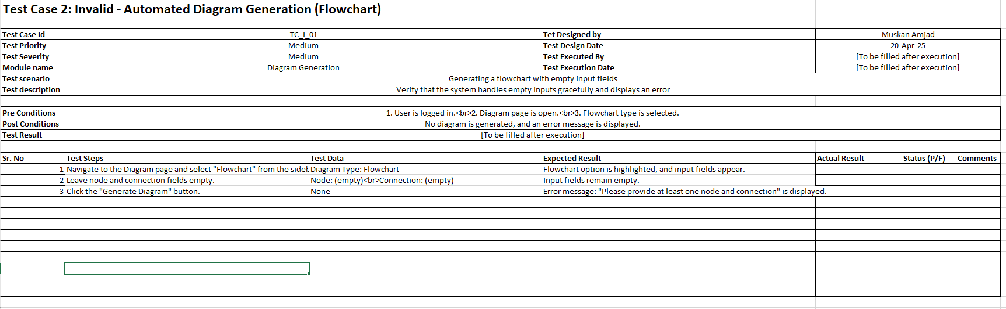

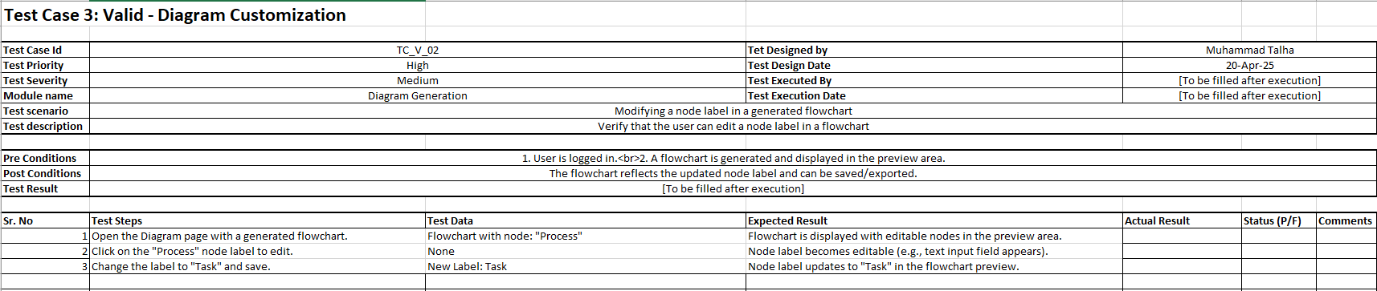

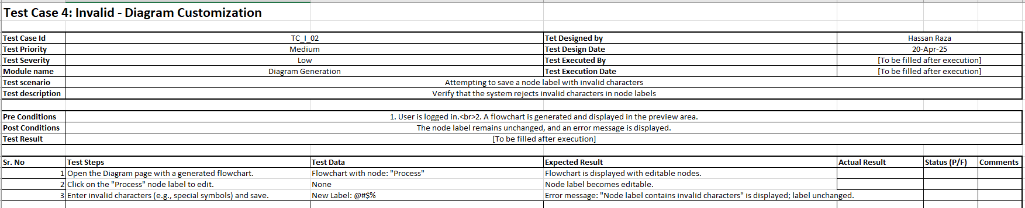

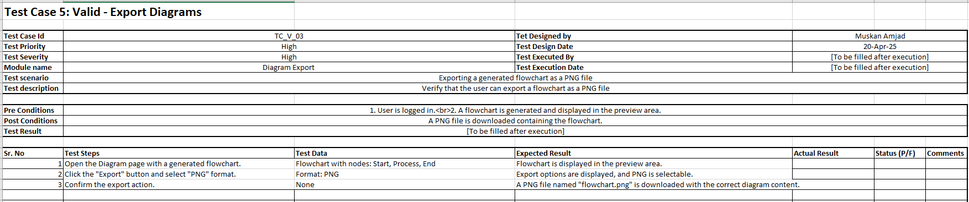

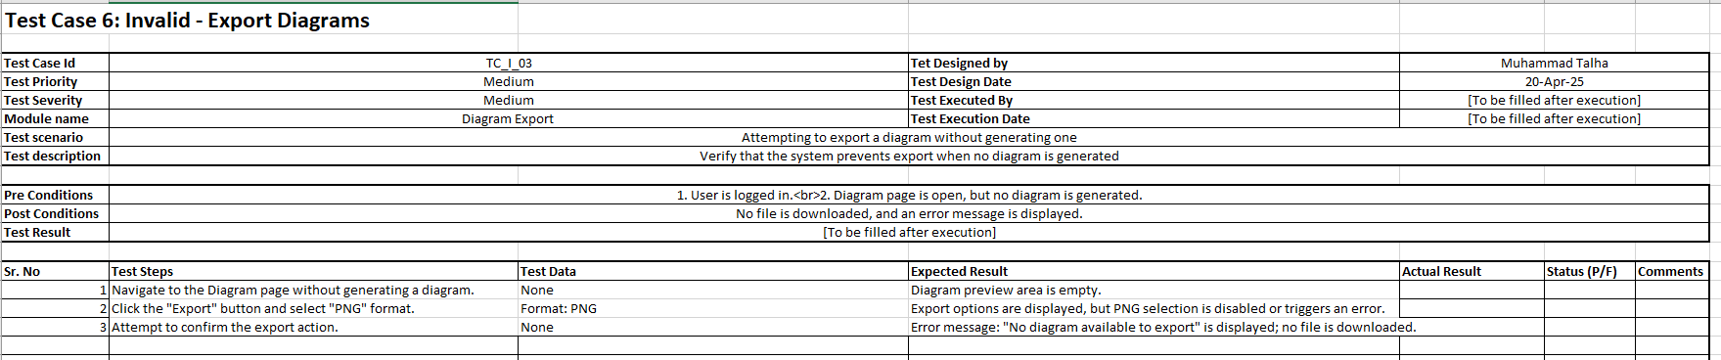

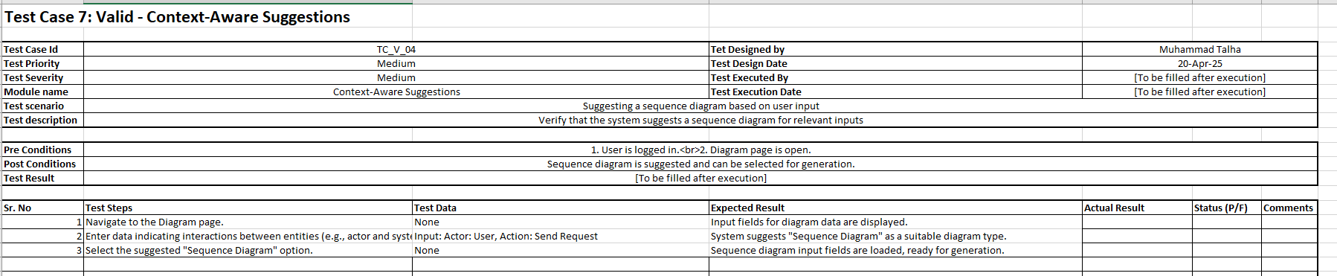

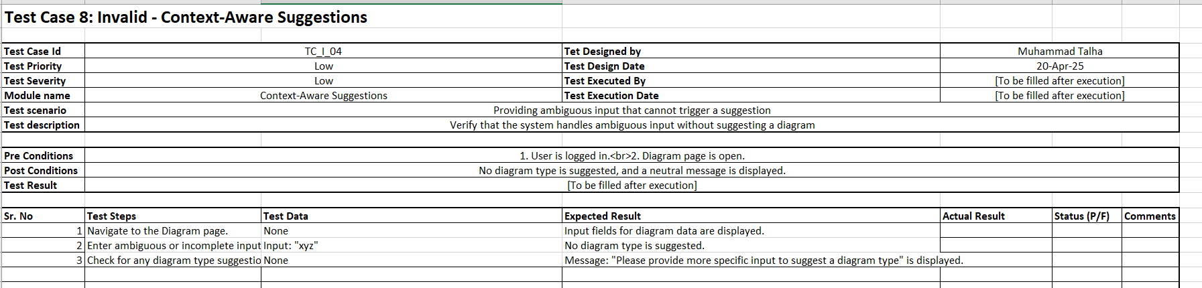

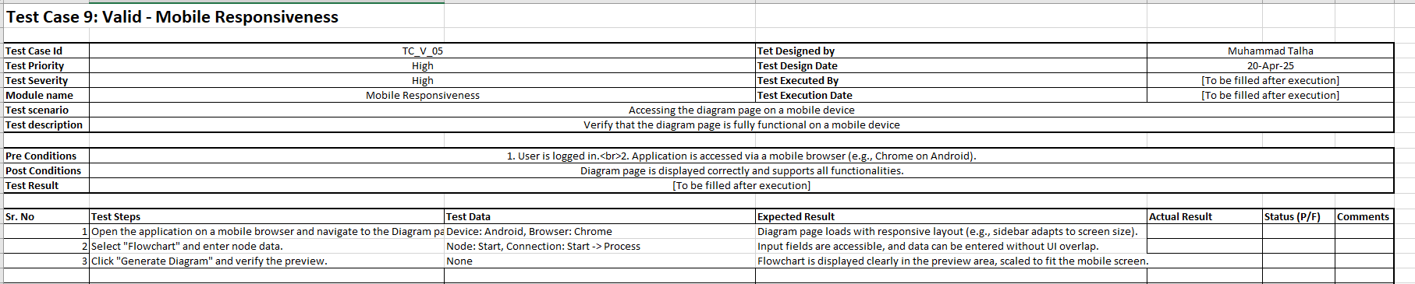

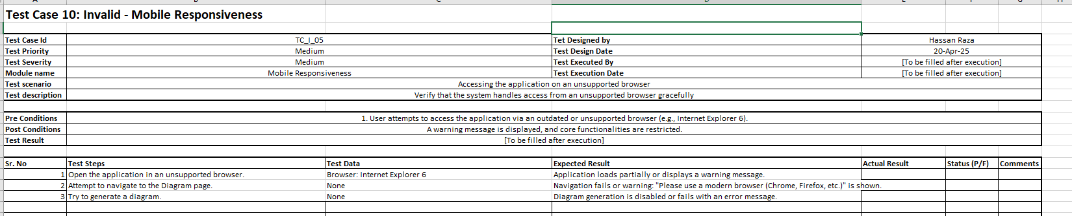

Summary of Test Results
<Provide in tabular form the defects found in each of your software modules. For example see Table 6.2 below.>

Table 6.2: Summary of Test Results
Module Name | Test cases run | Number of defects found | Number of defects corrected so far | Number of defects still need to be corrected
Features.js | [to be filled after execution]
ContactForm.js | …
Module 3 | …
… | …
 | …
 | …
 | …
Complete System | <Sum all of the above> | <Sum all of the above> | <Sum all of the above> | <Sum all of the above>

Revised Project Plan
<Show your progress and provide current status of the project in accordance with the plan provided in project proposal. Gantt chart should be used in this regard. Use Microsoft Office to develop the Gantt chart. Also provide an updated project plan. Provide list of modules that have been completed and the modules that still need more work. Use table 7.1 for this purpose.>
Table 6.2: Project Completion Status
Module Name | Status  (Complete, Partially Implemented, Not Implemented)
Homepage | Completed
Diagram Page | In Progress
Backend | Not Started
Complete System | In Progress

References
• React.js Documentation, https://reactjs.org
• Mermaid.js Documentation, https://mermaid.js.org
• jsPDF Documentation, https://github.com/parallax/jsPDF
• Create React App Guide, https://create-react-app.dev
Appendix A: Glossary
- SPA: Single Page Application
- Mermaid.js: JavaScript-based diagramming tool
- jsPDF: Library for generating PDF documents
Appendix B: IV & V Report
(Independent verification & validation)
IV & V Resource

Name Signature

S# | Defect Description | Origin Stage | Status | Fix Time
 |  |  |  | Hours | Minutes
1
2
3
…
Table 1: List of non-trivial defects

This document has been adapted from the following:
- Previous project templates at UCP
- High-level Technical Design, Centers for Medicare & Medicaid Services. (www.cms.gov)

